S.V.UNIVERSITY COLLEGE OF ENGINEERING::TIRUPATI
DEPARTMENT OF MECHANICAL ENGINEERING

Faculty Profile | 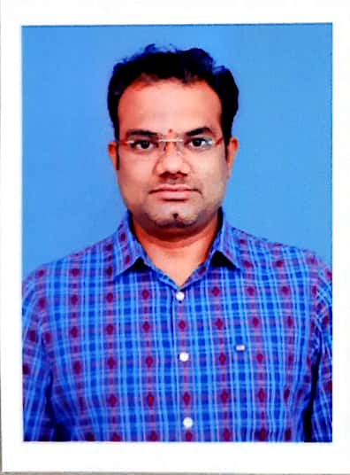
Name of the faculty | Mr. A.V.N.S. KIRAN
Date of Birth | 06/07/1991
Designation | Academic Consultant
Department | Mechanical Engineering
Qualification | M.Tech.,
Memberships | ISTE
Experience | Teaching: | Research:
Experience | 4
Publications | Journals | Conferences
Publications | 10 | 2
Workshops/Training Programmers | Organized | Participated
Workshops/Training Programmers | - | 15
Research Areas | ALTERNATE FUELS, IC ENGINES.
No. of M.Tech’s guided: | -
Ph.D’s supervision: | Awarded |  | Progress
Ph.D’s supervision: | - |  | -
Present Positions | -
Positions Held | -
Contact Details | +91-9492188838
Any Other details  (Research projects/academic activities etc) | -

Signature of faculty
(Mr. A.V.N.S. KIRAN)

